

International Border Community Air Monitoring Plan

February 2023

Table of Contents

List of Abbreviations iii

List of Figures v

List of Tables vi

Executive Summary 1

International Border Community 1

Air Pollution Monitoring 1

Roles and Responsibilities 2

Air Quality Data Processing 3

Community Engagement 4

Introduction 5

Section 1: Community Information 8

The International Border Community 8

Air Pollution Monitoring Targets 11

Particulate Matter 11

Diesel Particulate Matter 12

Volatile Organic Compounds (VOCs) 14

Airborne Metals 16

Odor-causing Air Pollution 17

Meteorology 18

Monitoring Sites and Sampling Plan 19

Community Input 20

Suitability 22

Field Sampling and Maintenance Plan 24

Roles and Responsibilities 27

San Diego County Air Pollution Control District 27

Contract Laboratories 28

California Air Resources Board 28

International Border Community Steering Committee 28

Casa Familiar 29

San Diego State University – School of Public Health 29

Mexican Government Agencies 29

Section 2: Air Monitoring Data 30

Quality Assurance and Control 30

Precision 31

Accuracy 31

Bias 32

Completeness 32

Data Control Limit Exceedances 32

Data Analysis and Management 33

Section 3: Community Engagement 35

Communicating Air Quality Information 35

Air Monitoring Data Subcommittee 35

Presentations and Reports 36

Publicly Available Data and Real-time Information 36

Program Evaluation 37

Future Actions 37

Community Emissions Reduction Program 37

Exposure Reduction 38

Land Use 38

Rule Development 38

Additional Monitoring 38

# List of Abbreviations

|  |  |
| --- | --- |
| **Abbreviation** | **Meaning** |
| AB-617 | California Assembly Bill 617 |
| APCD | San Diego County Air Pollution Control District |
| AQS | Air quality system database |
| ATV | All-terrain vehicle |
| BC | Black carbon |
| CA SR 905 | California State Route 905 |
| CAMP | Community Air Monitoring Plan |
| CAPP | Community Air Protection Program |
| CARB | California Air Resources Board |
| CBO | Community-based organization |
| CERP | Community Emissions Reduction Plan |
| CHD | Coronary heart disease |
| CHP | Monitoring site at United States Border Patrol checkpoint |
| CO | Carbon monoxide |
| CO2 | Carbon dioxide |
| COPD | Chronic obstructive pulmonary disease |
| DPM | Diesel particulate matter |
| DVN | Monitoring site at Donovan State Prison |
| EC | Elemental carbon |
| EC1 | Elemental carbon fraction *not* from diesel-engine sources |
| EC2 | Elemental carbon fraction from diesel-engine sources |
| ED | Emergency department |
| EPA | United States Environmental Protection Agency |
| GC-MS | Gas Chromatography + Mass Spectrometry |
| H2S | Hydrogen sulfide |
| HHSA | (San Diego County) Health and Human Services Agency |
| IBC | International Border Community |
| IBCSC | International Border Community Steering Committee |
| ICP-MS | Ion-coupled plasma mass spectrometry |
| NAAQS | National Ambient Air Quality Standards |
| NATTS TAD | National Air Toxics Trends Stations Technical Assistance Document |
| NO | Nitrogen monoxide |
| NO2 | Nitrogen dioxide |
| OEHHA | California Office of Environmental Health Hazard Assessment |
| PM | Particulate matter |
| PM10 | Particulate matter smaller than 10 micrometers |
| PM2.5 | Particulate matter smaller than 2.5 micrometers |
| POE | Port of entry |
| ppm | Parts per million |
| REL | Reference exposure level |
| SAY | Monitoring site at San Ysidro Fire Station 29 |
| SDSU | San Diego State University |
| SOP | Standard operating procedure |
| SSASS | Super speciation air sampling system |
| TOA | Thermal optical analyzer |
| TVOC | Total volatile organic compounds |
| µg/m3 | Micrograms per cubic meter |
| VOC | Volatile organic compound |

# List of Figures

Figure 1 Potential and current monitoring sites and pollution targets for each in the International Border Community 2

[Figure 2 Visual representation of precision, accuracy, and how they are different 3](https://sdcountycagov.sharepoint.com/sites/apcd/mts/SpcProj/Chemist/Shared%20Documents/CAMP/International%20Border%20Community/International%20Border%20Community%20Air%20Monitoring%20Plan%20-%20draft.docx#_Toc129098235)

Figure 3 Data analysis workflow followed by APCD chemists 4

Figure 4 CalEnviroScreen 4.0 map displaying traffic impact by census tract in the IBC. 8

[Figure 5 HHSA Map of 2019 asthma hospitalizations (left) and emergency department (ED) discharges (right) per 100,000 residents by region in San Diego County 9](https://sdcountycagov.sharepoint.com/sites/apcd/mts/SpcProj/Chemist/Shared%20Documents/CAMP/International%20Border%20Community/International%20Border%20Community%20Air%20Monitoring%20Plan%20-%20draft.docx#_Toc129098238)

[Figure 6 CalEnviroScreen map of cardiovascular disease percentile by census tract in San Ysidro 10](https://sdcountycagov.sharepoint.com/sites/apcd/mts/SpcProj/Chemist/Shared%20Documents/CAMP/International%20Border%20Community/International%20Border%20Community%20Air%20Monitoring%20Plan%20-%20draft.docx#_Toc129098239)

[Figure 7 Size comparison of PM10 and PM2.5 compared to human hair and beach sand 11](https://sdcountycagov.sharepoint.com/sites/apcd/mts/SpcProj/Chemist/Shared%20Documents/CAMP/International%20Border%20Community/International%20Border%20Community%20Air%20Monitoring%20Plan%20-%20draft.docx#_Toc129098240)

[Figure 8 a) a clean, unused filter; b) filter is prepared for deployment by placement in a protective cassette; c) a discolored filter after sampling, ready for shipment to contract laboratory for analysis 13](https://sdcountycagov.sharepoint.com/sites/apcd/mts/SpcProj/Chemist/Shared%20Documents/CAMP/International%20Border%20Community/International%20Border%20Community%20Air%20Monitoring%20Plan%20-%20draft.docx#_Toc129098241)

[Figure 9 A Met One BC-1060 Black Carbon Monitor 13](https://sdcountycagov.sharepoint.com/sites/apcd/mts/SpcProj/Chemist/Shared%20Documents/CAMP/International%20Border%20Community/International%20Border%20Community%20Air%20Monitoring%20Plan%20-%20draft.docx#_Toc129098242)

[Figure 10 VOC sampling apparatus including stainless steel canister, timer, and flow controller 15](https://sdcountycagov.sharepoint.com/sites/apcd/mts/SpcProj/Chemist/Shared%20Documents/CAMP/International%20Border%20Community/International%20Border%20Community%20Air%20Monitoring%20Plan%20-%20draft.docx#_Toc129098243)

[Figure 11 A Met One E-Sequential sampling for ambient airborne metals at APCD's DVN monitoring site 16](https://sdcountycagov.sharepoint.com/sites/apcd/mts/SpcProj/Chemist/Shared%20Documents/CAMP/International%20Border%20Community/International%20Border%20Community%20Air%20Monitoring%20Plan%20-%20draft.docx#_Toc129098244)

[Figure 12 A continuous air monitoring sensor assembly mounted to a pole 17](https://sdcountycagov.sharepoint.com/sites/apcd/mts/SpcProj/Chemist/Shared%20Documents/CAMP/International%20Border%20Community/International%20Border%20Community%20Air%20Monitoring%20Plan%20-%20draft.docx#_Toc129098245)

[Figure 13 Schematic of atmospheric boundary layer heights during winter and summer 18](https://sdcountycagov.sharepoint.com/sites/apcd/mts/SpcProj/Chemist/Shared%20Documents/CAMP/International%20Border%20Community/International%20Border%20Community%20Air%20Monitoring%20Plan%20-%20draft.docx#_Toc129098246)

[Figure 14 Annotated map of the entire IBC, including areas of concern highlighted by IBCSC members 20](https://sdcountycagov.sharepoint.com/sites/apcd/mts/SpcProj/Chemist/Shared%20Documents/CAMP/International%20Border%20Community/International%20Border%20Community%20Air%20Monitoring%20Plan%20-%20draft.docx#_Toc129098247)

[Figure 15 Annotated map of San Ysidro, highlighting areas of concern cited by IBCSC members 21](https://sdcountycagov.sharepoint.com/sites/apcd/mts/SpcProj/Chemist/Shared%20Documents/CAMP/International%20Border%20Community/International%20Border%20Community%20Air%20Monitoring%20Plan%20-%20draft.docx#_Toc129098248)

Figure 16 Annotated map of Otay Mesa, highlighting areas of concern cited by IBCSC members 21

Figure 17 Visual summary of APCD’s process for gathering sampling data, performing analysis, and communicating results and trends to IBCSC and IBC residents 30

[Figure 18 Visual representation of precision, accuracy, and how they are different 31](https://sdcountycagov.sharepoint.com/sites/apcd/mts/SpcProj/Chemist/Shared%20Documents/CAMP/International%20Border%20Community/International%20Border%20Community%20Air%20Monitoring%20Plan%20-%20draft.docx#_Toc129098251)

[Figure 19 Presentation to IBCSC members at the San Ysidro Civic Center during the October 2022 Steering Committee Meeting 36](https://sdcountycagov.sharepoint.com/sites/apcd/mts/SpcProj/Chemist/Shared%20Documents/CAMP/International%20Border%20Community/International%20Border%20Community%20Air%20Monitoring%20Plan%20-%20draft.docx#_Toc129098252)

# List of Tables

Table 1 Members and affiliations of the International Border Community Steering Committee 6

Table 2 Tabulated asthma hospitalizations and emergency department (ED) discharges per 100,000 residents by region in San Diego County in 2019. 10

Table 3 Current air monitoring sites in IBC 24

Table 4 Potential sites for air monitoring in the IBC 24

Table 5 Maintenance tasks and frequency by program, equipment type 26

# Executive Summary

## International Border Community

The International Border Community was selected for the Community Air Protection Program by the California Air Resources Board (CARB) in February 2022. This program requires the development of a Community Air Monitoring Plan (CAMP) and a Community Emissions Reduction Program (CERP). To co-develop these programs and facilitate communication between air quality professionals and community residents, the International Border Community Steering Committee was formed, comprised of individuals who live, work, or own a business within the community boundaries, and partner organizations who have an interest and role in improving air quality in the community. The community experiences air pollution from numerous sources, including heavy traffic near the ports of entry in San Ysidro and Otay Mesa, dust from offroad vehicles used by Border Patrol agents, freight trains and rail yards, industry, warehouses and associated heavy-duty truck traffic, construction, untreated wastewater in the Tijuana River, and two airports: Brown Field Municipal Airport and Tijuana International Airport. Data from various government agencies shows elevated rates of asthma and cardiovascular disease among International Border Community residents, who also report frequent headaches and nausea.

### Air Pollution Monitoring

The CAMP incorporated community feedback, health information, and existing air monitoring data. Based on this information, the San Diego County Air Pollution Control District (APCD) has decided to monitor for the following types of air pollution:

* Particulate matter
* Diesel particulate matter
* Volatile organic compounds
* Airborne metals
* Odor-causing chemicals

In addition to these monitoring priorities, the APCD will gather meteorological data to analyze the effects that weather and climate can have on air pollution levels and community exposure. Air monitoring instruments will include continuous sensors, which provide near-real-time data, and instruments that collect samples over a 24-hour period. 24-hour samples will be sent to third-party contract laboratories for analysis. Routine maintenance, including calibrations, flow and leak checks, audits, and more will be performed on all equipment to ensure data quality and instrument performance.

Monitoring is already conducted at two sites within the International Border Community: at monitoring sites at Donovan State Prison and San Ysidro Fire Station #29. Additional monitoring sites will be constructed based on community feedback, location suitability, and available resources, including equipment and staff. A monitoring site at the California Highway Patrol Commercial Vehicle Enforcement Facility at the Otay Mesa port of entry is currently in development. Additional locations of interest include the San Ysidro port of entry, the Tijuana River Valley, Brown Field Municipal Airport, schools, parks, senior centers, along California State Route 905, and near warehouses and other areas affected by heavy-duty truck traffic. Additional monitoring is conducted on the Mexican side of the border at the United States Consulate General near the Tijuana International Airport, and various particulate matter sensors are deployed in Tijuana by the State of Baja California. More information on these particulate matter sensors can be found on the [Purple Air website](https://map.purpleair.com/1/mAQI/) <purpleair.com>.

Figure 1 Potential and current monitoring sites and pollution targets for each in the International Border Community

### Roles and Responsibilities

Community air monitoring and the Community Air Protection Program more broadly rely on multiple agencies and groups to coordinate with one another. APCD and CARB perform the bulk of air sampling and data analysis, with CARB providing technical and monitoring support to APCD. The International Border Community Steering Committee serves as a liaison between the residents of the community and the government agencies. Casa Familiar, a community-based organization in the International Border Community, and the San Diego State University School of Public Health regularly contribute to Steering Committee meeting discussions and perform some air monitoring and sampling as well. Finally, CARB and APCD meet regularly with representatives of Mexican government agencies to assess the monitoring network on each side of the border and share the latest efforts and results with one another.

## Air Quality Data Processing

All air quality data is processed to ensure that it passes various quality assurance and control metrics. Data must be accurate, precise, complete, and without bias. Data is accurate when a measured value matches the true, actual value. Precision means that a sample run multiple times gives the same results with repetition. Completeness refers to the amount of data that meets quality requirements as a fraction of the entire pool of data. Data is biased when different results are obtained by different personnel or equipment, which should not happen. Routine maintenance helps prevent data bias while ensuring accuracy, precision, and completeness.  
  
APCD chemists perform thorough review on all data, including continuous sampler data and analysis reports from third-party laboratories. Besides verifying quality, chemists also examine the trends in pollution levels over time, the effects that the weather and time of day have, how different areas of the community are affected differently, and more.

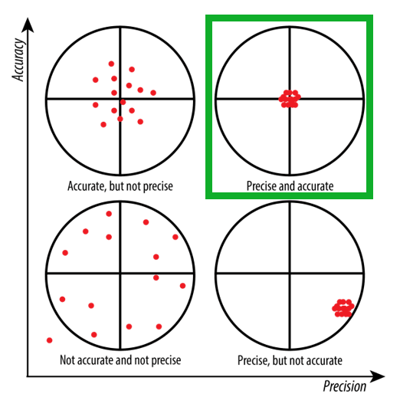

Figure 2 Visual representation of precision, accuracy, and how they are different. Precision answers whether analyzing the same sample multiple times produce the same results, while accuracy measures how close a measurement is to the actual, “true” value. In the top right, the ideal scenario is shown surrounded by a green box: simultaneously high precision **and** accuracy.

Figure 3 Data analysis workflow followed by APCD chemists

## Community Engagement

The International Border Community, its Steering Committee, and community members are crucial to the success of this program. Ongoing communication will be essential to maintaining the program, both to evaluate past and present efforts and to identify future actions to improve air quality. APCD and CARB will make air pollution data available to the community in a variety of ways, including through presentations, subcommittee meetings, progress reports, and making data available online. Air pollution data will help identify steps that community residents can take in their day-to-day lives to reduce their exposure to harmful air pollutants. This data will also help assess the effectiveness of the Community Emissions Reduction Program (CERP), which is a document currently under development that will identify strategies to reduce air pollution in the community.

# Introduction

In response to California Assembly Bill 617 (AB-617) [C. Garcia, Chapter 16, Statutes of 2017], the California Air Resources Board (CARB) established the Community Air Protection Program (CAPP). The CAPP focuses on reducing exposure to air pollutants in the most impacted communities in the state.

The San Diego County Air Pollution Control District (APCD) nominated the International Border Community (IBC) of San Diego to be included in this CARB-funded program. The IBC includes San Ysidro and Otay Mesa, both of which contain one international port of entry (POE) from Mexico. In February 2022, the IBC was approved by CARB for the CAPP. Once a community is approved for the CAPP, the local air monitoring agency is required to develop two major documents: the Community Air Monitoring Plan (CAMP) and the Community Emissions Reduction Program (CERP).

The CAMP details what air quality challenges are faced by the community, outlines how air monitoring data will be collected and communicated to the community, and lays out actionable approaches to reducing air pollution in the community. The CERP incorporates information from the CAMP and identifies strategies to both reduce air pollution at the source and prevent community exposure to harmful pollutants.

More information can be found at the following webpages:

[International Border Community (sdapcd.org)](https://www.sdapcd.org/content/sdapcd/community/community-air-protection-program/international-border-community.html)

[International Border Community | California Air Resources Board](https://ww2.arb.ca.gov/our-work/programs/community-air-protection-program/communities/international-border-community)

Community engagement is a crucial part of any successful CAPP. The community members and stakeholders know their local neighborhoods better than anyone else, and therefore they can provide essential information and feedback to the APCD during the development of the monitoring plan and beyond. Thus, the International Border Community Steering Committee (IBCSC) was formed. Members of the committee include individuals who live, work, or own a business within the community borders; representatives for community-based organizations (CBOs); public health researchers from San Diego State University (SDSU); representatives from land use jurisdictions and local government decision makers; regional and transportation planning agencies; and local businesses and business associations. An initial stakeholder meeting was conducted on March 16, 2022, to share information about the CAPP and the desired partnership with the community and to invite interested parties to be part of the IBCSC. The IBCSC held its first meeting on April 20, 2022, and meetings have continued to be held on the third Wednesday of each month at 5 pm, barring conflict with major holidays. Meetings have primarily been held remotely via Zoom in the aftermath of the Covid-19 pandemic, but future in-person meetings have been proposed on a quarterly basis, pending availability by IBCSC members. For more information on IBCSC meetings, membership, and charter, please visit APCD’s dedicated [IBC webpage](https://www.sdapcd.org/content/sdapcd/community/community-air-protection-program/international-border-community.html). A current roster of IBCSC members is shown in Table 1.

Table 1 Members and affiliations of the International Border Community Steering Committee

|  |  |
| --- | --- |
| **Name** | **Affiliation** |
| Manuela Castaneda | Community member |
| Olga Espinoza | Community member |
| Wendy Barrientos | Community member |
| Rudy Lopez | Community member |
| Juan Miguel Hornedo | San Ysidro Chamber of Commerce (alternate) |
| Jason Wells | San Ysidro Chamber of Commerce |
| Mariano Munoz | Community member |
| Alejandro Amador | Casa Familiar- CBO |
| Stanford Morrison | GRID Alternatives- CBO |
| Lesly Gallegos-Stearns | Casa Familiar- CBO |
| Jenny Quintana | SDSU- Researcher |
| Diane Vermeulen | Caltrans |
| Shelby Buso | City of San Diego |
| Irma Zepeda | Community member |
| Christopher Roberts | Otay Industry |
| Janett Gaytan | Community member |
| Maria Gamez | Community member |
| Marie Vicario | Community member |
| Mauricio Vitela | Community member |
| Guadalupe Gomez | Community member |
| Tellez Maricela | Community member |
| David Flores | Community member |
| Tellez Trinidad | Community member |
| Li Hanyang | SDSU- Researcher |
| Escalante Elsa | Community member |
| Gerardo-Chavarin Maritza | Community member |
| Zach Hernandez | SANDAG |
| Mariela Rodriguez | SANDAG |

The aspects of the AB-617 air monitoring program are dynamic, so the webpages above are the best places to find the most current information regarding this program. Specific webpages and sources of current information will be referenced in this document as appropriate. ***This*** ***Community Air Monitoring Plan describes the Community Air Protection Program in the IBC, the composition of the Steering Committee, and how the AB-617 air monitoring program is organized and operated by APCD.***  The CAMP is divided into three main sections: Section 1: Community Information, Section 2: Air Monitoring Data, and Section 3: Community Engagement. In the interest of the length and accessibility of this document, some of the technical details will be included separately in the Supplemental Document, which will be published alongside the CAMP, or in standard operating procedures (SOPs), which summarize specific aspects of air monitoring and are available upon request.

APCD has strived to include all relevant information shared by the community about the Community Air Monitoring Plan in this document. However, due to the dynamic nature of this program, not all developments may be up to date, and this document will only be revised upon major additions or changes to the program. Examples of events that could lead to a CAMP revision include:

* Addition/decommissioning of a monitoring site or project
* Procurement of new air monitoring equipment/instruments
* Vital CAMP information out of date

When a CAMP revision is performed, the IBCSC and CARB will both be notified and provided with an updated draft for their approval. Readers of this document are encouraged to provide feedback regarding the program and/or this document to APCD at any time.

# Section 1: Community Information

## The International Border Community

The IBC faces unique air quality challenges directly and indirectly linked to its proximity to the San Ysidro and Otay Mesa ports of entry, two of the busiest land border crossings in the world, as well as the city of Tijuana. Air from the Mexican side of the border can contain pollution from open burning of trash and other items, industrial-related emissions, and underregulated vehicle emissions. Wastewater is also transmitted across the border via the Tijuana River, prompting frequent complaints from IBC members and residents of odors, headaches, nausea, and overall poor quality of life.

In addition, heavy traffic at the San Ysidro and Otay Mesa ports of entry leads to large quantities of idling cars and trucks, which emit hazardous air pollution including diesel particulate matter as they wait to cross the border. Figure 4 shows a graphic from CalEnviroScreen, a mapping tool prepared by the California Office of Environmental Health Hazard Assessment (OEHHA). Data indicate that both San Ysidro and Otay Mesa rank in the 100th percentile for traffic density among all the census tracts of California.

Figure 4 CalEnviroScreen 4.0 map displaying traffic impact by census tract in the IBC. *The traffic densities in both Otay Mesa and San Ysidro rank in the 100th percentile for California.*

Community steering committee members also notified APCD of other vehicle-related air pollution concerns, including:

* Dust from Border Patrol all-terrain vehicles (ATVs) and vehicles operating on the west side of San Ysidro
* Emissions from freight trains and rail yard going through the heart of San Ysidro
* Operations at Amazon warehouses, including current and proposed expansions
* Future impacts to people living in new housing developments near freeways and warehouses, especially along California State Route 905 (CA SR 905)
* Current impacts to children and elderly at schools, parks, and senior centers near freeways and busy traffic corridors
* Traffic circulation near or around Las Americas Premium Outlets, Dairy Mart Rd., Calle Primera, Willow Rd., Camino De La Plaza, East San Ysidro Blvd., and more
* Pollution from both Brown Field Municipal Airport in Otay Mesa and Aeropuerto Abelardo L. Rodriguez in Tijuana.

APCD does not have authority to place monitors or instruments on the Mexican side of the border, so monitoring on the United States side of the border will be crucial to understanding the air quality impact on the IBC from sharing a border with Tijuana.  
The community also raised respiratory health and other conditions that can be exacerbated by air pollution, including asthma, chronic obstructive pulmonary disease (COPD), mental health, vascular, and other chronic diseases**. Per data available from the San Diego County Health and Human Services Agency (HHSA), the South Region of San Diego County exceeds the County average rates in hospitalizations and emergency department (ED) discharges in asthma, pneumonia, coronary heart disease (CHD), and COPD.**

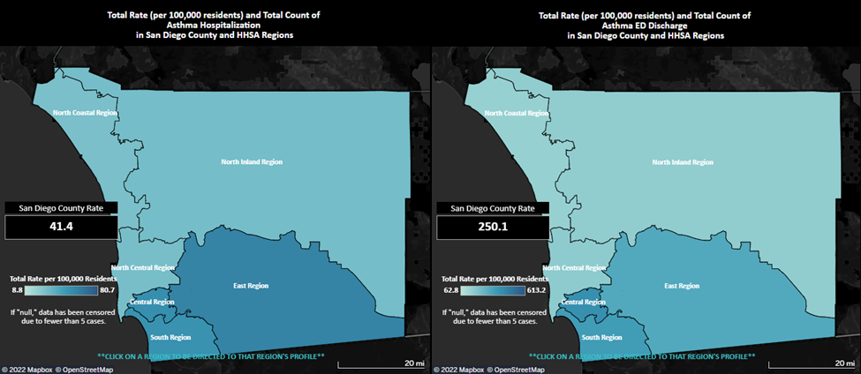

Figure 5 HHSA Map of 2019 asthma hospitalizations (left) and emergency department (ED) discharges (right) per 100,000 residents by region in San Diego County. See Table 1 for tabulated data.

Figure 5 and Table 2 provide data on asthma rates in San Diego County, while Figure 6 shows a CalEnviroScreen map of cardiovascular disease in San Ysidro. For more detailed information, please visit the HHSA [Regional & Community Data (sandiegocounty.gov)](http://www.sandiegocounty.gov/content/sdc/hhsa/programs/phs/community_health_statistics/regional-community-data.html#CommunityHealthProfiles) webpage and the [CalEnviroScreen 4.0 | OEHHA](https://oehha.ca.gov/calenviroscreen/report/calenviroscreen-40) mapping tool.

Table 2 Tabulated asthma hospitalizations and emergency department (ED) discharges per 100,000 residents by region in San Diego County in 2019; IBC is contained within South Region, highlighted below.

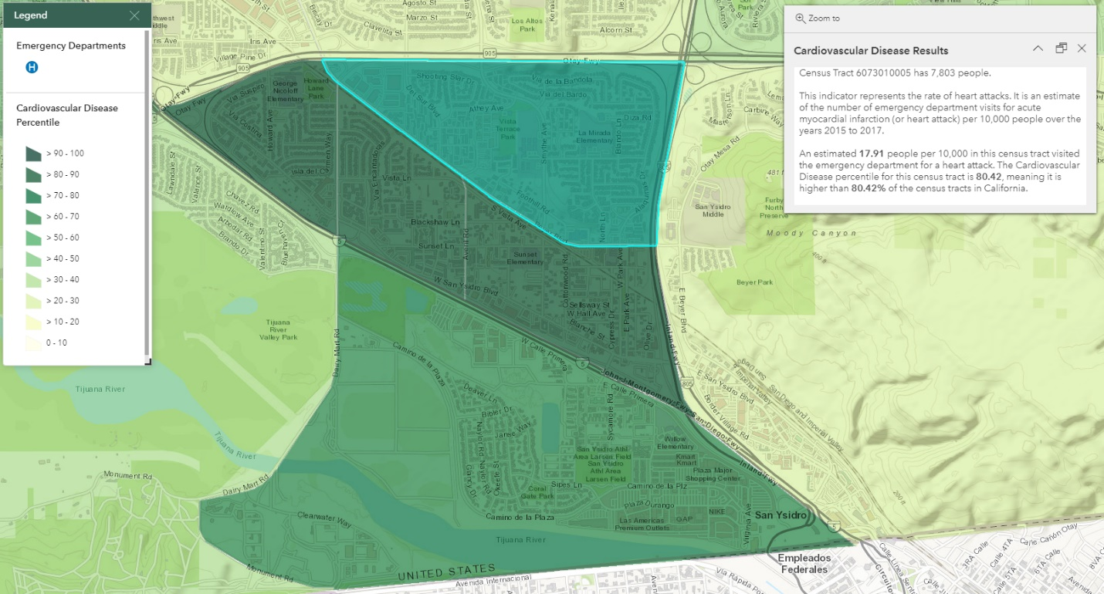

Figure 6 CalEnviroScreen map of cardiovascular disease percentile by census tract in San Ysidro. The census tracts in San Ysidro contained within Interstate 5, Interstate 805, and California State Route 905 rank in the 80th percentile for cardiovascular disease

|  |  |  |
| --- | --- | --- |
| **Region** | Asthma Hospitalizations per 100,000 Residents | Asthma ED Discharges per 100,000 Residents |
| County Average | 41 | 250 |
| North Coastal | 29 | 149 |
| North Central | 30 | 169 |
| Central | 54 | 405 |
| South | 53 | 361 |
| East | 60 | 311 |
| North Inland | 31 | 163 |

## Air Pollution Monitoring Targets

Feedback from the IBCSC, historical knowledge, and data from various air monitoring agencies, along with the information presented above, have enabled APCD to select specific chemical compounds to target for monitoring:

### Particulate Matter

Particulate matter (PM) is air pollution made up of solid and liquid particles small and light enough to remain airborne for days to weeks. While some PM is visible to humans, much of this class of pollution can only be viewed with powerful electron microscopes that can view objects in the micrometer size range. A micrometer is one millionth of a meter. Figure 7 shows how small PM10 and PM2.5 are compared to a human hair. From an air monitoring standpoint, particulate matter smaller than 10 micrometers (PM10) and 2.5 micrometers (PM2.5) are most frequently targeted. PM is also an EPA criteria pollutant, meaning there are National Ambient Air Quality Standards (NAAQS) that state and local air districts must meet; criteria pollutant levels above NAAQS result in a “non-attainment” status, prompting further action by air monitoring agencies to reduce the ambient levels. APCD will compare PM data to the annual and 24-hour NAAQS, which are 12.0 micrograms per cubic meter (µg/m3) and 35 µg/m3, respectively. If data shows that PM levels exceed the NAAQS, APCD will notify the IBCSC and prioritize PM levels in the CERP.

PM can be emitted from sources such as construction, offroad vehicle activity, fires, and more, or produced from complex chemical reactions between gases in the atmosphere. PM10 and PM2.5 are small enough to penetrate deep into lung tissue and even the bloodstream, which can result in serious health problems including cancer. Beyond health impacts, PM is a leading cause of haze, which reduces visibility.

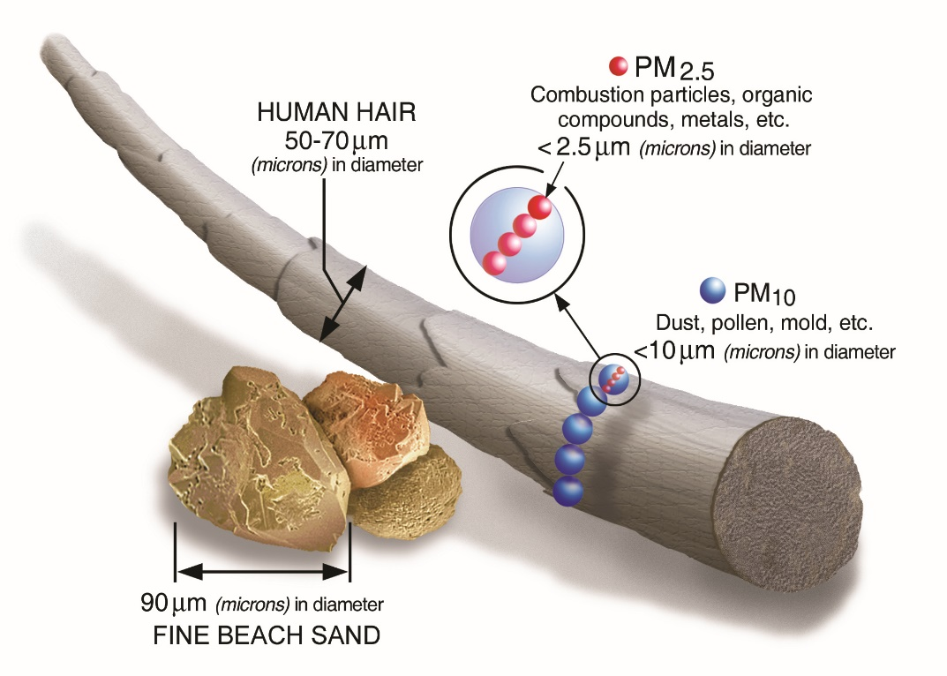

Figure 7 Size comparison of PM10 and PM2.5 compared to human hair and beach sand; micrometer is shorthand for micrometer

PM has been monitored in San Diego County as part of APCD’s regulatory monitoring program, including in the IBC in Otay Mesa and briefly at the San Ysidro POE. APCD will continue monitoring at DVN, but new, continuous monitors have been deployed to replace old, filter-based instruments. APCD will utilize a combination of different instruments to measure PM, including the Teledyne T640X and Purple Air sensors.

### Diesel Particulate Matter

Diesel particulate matter (DPM), a subset of PM, is a byproduct of incomplete fossil fuel combustion found in the exhaust from trucks, buses, trains, ships, and other diesel-powered equipment. DPM contains hundreds of distinct chemicals, many of which have the potential to cause cancer (carcinogenic), such as benzene and naphthalene. Like PM, DPM can be small enough to penetrate deep into lung tissue and enter the bloodstream and contribute to a range of health problems, including:

* Irritation and inflammation of eyes, nose, and throat
* Heart disease
* Bladder and lung cancer
* Lung disease (e.g., COPD)
* Asthma
* Respiratory allergies
* Cancer

Beyond direct health impacts, DPM can also substantially reduce visibility and contribute to climate change. With the prevalence of truck traffic passing through the IBC, the APCD has determined that DPM monitoring will be critical. Monitoring will depend on two different types of sampling in the IBC: discrete, filter-based monitoring of elemental carbon (EC), and continuous, optical-based monitoring of black carbon (BC), both of which measure markers of DPM.

EC sampling involves capturing particles smaller than 2.5 micrometers in diameter on a filter. The filter is encased in a cassette, shielding it from the environment and potential contamination, in an instrument called the Met One Super Speciation Air Sampling System (SSASS). **Error! Reference source not found.** shows a clean filter, an APCD chemist preparing a filter for sampling, and a filter after at his been used for sampling. APCD will collect 24-hour filter samples every six days, and additional samples can be taken for special projects and targeted sampling. The filter-based samples will be analyzed using an instrument called a thermal optical analyzer (TOA) which separates the collected particles into two fractions: particles from non-diesel engine sources (EC1) and particles from diesel engines (EC2). This allows us to assess whether an increase in pollution levels is due to diesel-based engines or other sources. While this measurement technique is precise and accurate, the 24-hour collection time method will not reveal time-of-day (diurnal) patterns in the data.

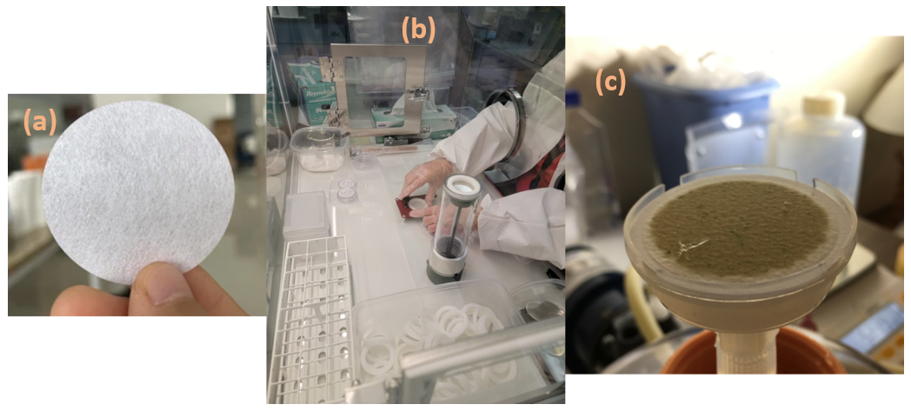

Figure 8 a) a clean, unused filter; b) filter is prepared for deployment by placement in a protective cassette; c) a discolored filter after sampling, ready for shipment to contract laboratory for analysis

BC monitoring will be performed using a continuous, optical-based instrument that works by measuring how light is scattered by an air sample: the Met One BC1060, shown in Figure 9. Although EC and BC are both markers for DPM, they differ in how they are measured (i.e., EC measurements are discrete and filter based, while BC measurements are continuous and optical sensor-based). While continuous BC monitoring is typically less precise than the filter-based technique, the continuous data provided by the BC1060 allows for multiple analyses, including time-of-day (diurnal) and weather-related effects. Side-by-side (collocated) deployment of both measurement techniques will allow for precise DPM concentration measurements and analysis of how the two techniques correlate.

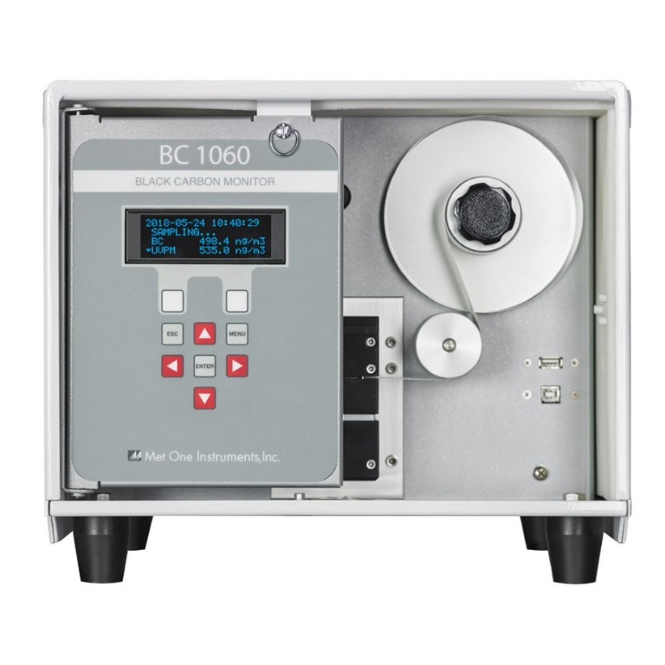

Figure 9 A Met One BC-1060 Black Carbon Monitor

OEHHA has established a chronic reference exposure level (REL) of 5 µg/m3, meaning that long term exposure to concentrations below 5 µg/m3 are not expected to result in adverse health effects. APCD will compare DPM data to this REL and monitor long term trends, alerting the community to elevated levels and setting emission reduction goals within the CERP.

In addition to APCD-led monitoring, CARB will also contribute monitoring personnel and equipment for a one-year period while APCD ramps up its monitoring efforts. CARB’s project will measure the concentrations of pollutants (i.e., particulate matter, nitrogen dioxide, and BC) related to local sources, including vehicle emissions from the San Ysidro POE and nearby freeways, as well as transport of pollutants from Mexico. CARB is responsible for purchasing and deploying the monitors and has worked with SDAPCD and community steering committee members to identify potential monitoring site locations. CARB will continue the collaborative effort with community members to operate and maintain the monitors throughout the duration of the project.

Building off the community engagement efforts and information gathered on community priorities for CARB’s San Ysidro 1-Year Monitoring Pilot Project, CARB conducted a mobile monitoring study in San Ysidro in Fall 2022. CARB is responsible for preparing equipment and conducting mobile monitoring and processing and analyzing the mobile monitoring data.

The main goals of the mobile monitoring project are to

* Identify hot spots of 10+ pollutants
* Identify potential locations for additional air monitoring

CARB will work with SDAPCD to understand the best way to share data analysis with the community steering committee in an accessible manner. CARB will also provide technical guidance on developing and using mobile platforms and implementing and using air monitoring equipment on mobile platforms. There may be opportunities to conduct additional mobile monitoring (potentially adding other pollutants) in the IBC based on needs.

### Volatile Organic Compounds (VOCs)

VOCs are a broad class of chemicals characterized by their tendency to release vapors from a solid or liquid state. Vapors can be released from liquids used to dissolve other substances (solvents), industrial activity, fuel combustion from automobile engines or electricity generation, and more. Each VOC varies from the next in terms of hazard, toxicity, health effects, etc. Generally, VOCs are associated with the following health effects:

* Irritation and inflammation of eyes, nose, and throat
* Headaches and dizziness
* Nausea
* Exacerbation of existing respiratory health problems, such as asthma
* Cancer
* Liver, kidney, and central nervous system damage

Besides direct health impacts, VOCs also contribute to the formation of ozone, which, like PM, is an EPA criteria pollutant. Ozone inflames and damages lungs and airways, exacerbates asthma and other respiratory illnesses, and causes coughing and sore throat.

Historically in the IBC, APCD sampled for VOCs at the Donovan State Prison monitoring site (DVN) in Otay Mesa, as well as at other monitoring sites around San Diego County. **The AB-617 program will enable APCD to expand VOC monitoring to multiple sites within the IBC.** Two types of sampling will be employed: discrete, canister-based air samples and continuous total VOC (TVOC) sensors.

Figure 10 VOC sampling apparatus including stainless steel canister, timer, and flow controller

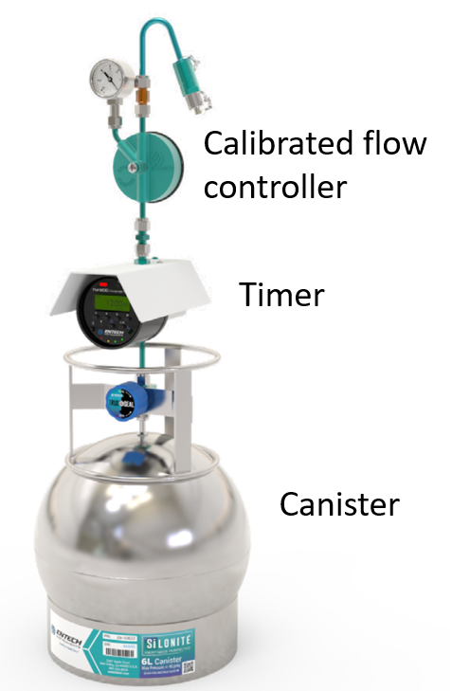

**Canister-based sampling** involves capturing air samples into an evacuated stainless-steel canister (see Figure 10). **APCD will collect 24-hour samples every six days.** Additional samples can be taken for special monitoring projects and targeted sampling. These canisters are specially treated to ensure the air sample does not degrade during storage. The canister has a valve that is opened during sampling. The valve is attached to a timer, which determines when sampling begins, and a flow restrictor, which is calibrated to ensure the specific 24-hour sampling duration is achieved. The canisters deliver the air samples to an instrument called a gas chromatograph – mass spectrometer (GC-MS), which separates chemicals and measures the amount of each target VOC contained in the sample. APCD will monitor 56 distinct VOCs, which are listed in the Supplemental Document.

TVOC sensors generally operate either with an optical-based, light-scattering method (similar to the BC1060) or an electrochemical method, which relies on very specific chemical reactions that produce measurable electrical signals that increase proportionally to the amount of VOCs chemical in the air. Continuous sensors offer the advantage of data measurements on a minute-by-minute basis every day. This data enables multiple analyses including weather effects, time-of-day (diurnal) impact, and more. Additionally, the installation and maintenance burdens with TVOC sensors are minimal. APCD is in the process of allowing companies to submit bids for consideration of their sensor technologies. Sensors will be deployed to the Tijuana River Valley and surrounding residential areas. Data will be transmitted through a cellular network for real-time viewing and rapid analysis.

While the advantage of continuous data will certainly aid APCD in monitoring and characterizing VOC pollution, it is important to note two key advantages that canister-sampling holds over the continuous sensors: speciation and sensitivity. Speciation means that canister-sampling can not only detect VOCs but can also differentiate between the exact chemicals in the air sample. Sensitivity means that the canister-based sampling can provide concentration values at much lower levels than the continuous sensor. Although canister-sampling cannot provide minute-by-minute data, it can provide more specific information on which chemicals are in the air, how plentiful they are in the air sample, all while detecting these chemicals at lower levels than the continuous sensor. Both type of monitors used together will give APCD and the community a better understanding of air quality in the IBC.

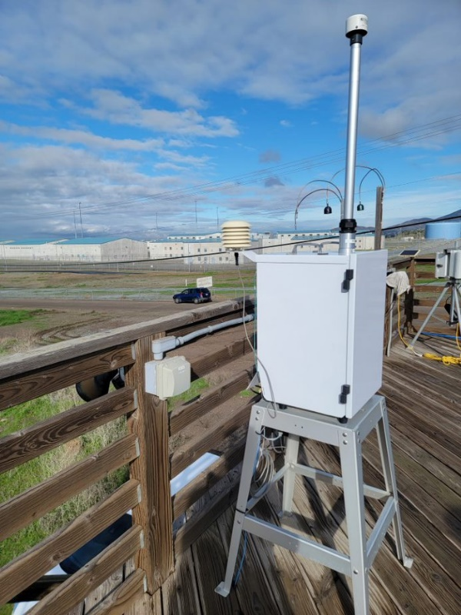

Figure 11 A Met One E-Sequential sampling for ambient airborne metals at APCD's DVN monitoring site

### Airborne Metals

Metallic compounds, such as chromium, copper, and lead, can be emitted into ambient air from industrial activity, fuel combustion (including from motor vehicles and electricity generation), resuspension from roadside dust, tire wear, brake wear, landfills, scrapyards, and more. Toxic metals can damage the cardiovascular system following long-term exposure. APCD has been measuring toxic metals in the IBC at DVN every six days since 2016 (see Figure 11), with a brief hiatus in 2019. We will continue to monitor these elements and others that are emitted from the mixture of industrial and transportation sources that originate on both sides of the border.

Metals sampling will be performed by collecting air samples on filters at IBC monitoring sites. As with EC sampling, filters are encased in a stainless-steel canister to prevent contamination, and 24-hour samples are collected every six days.

Filters undergo a complex chemical process by which the metal compounds are extracted and analyzed with a technique called Ion-coupled plasma mass spectrometry (ICP-MS), which separates the metals based on chemical characteristics so each concentration can be individually measured. The full list of target metals can be found in the Supplemental Document.

Like VOCs, metals have cancer and noncancer risk levels provided by the EPA in the NATTS TAD. APCD will compare measured concentrations to these values to both educate the public on their exposures and refine emissions reduction goals to specifically target compounds at elevated levels.

### Odor-causing Air Pollution

Unpleasant environmental odors come from many sources including wastewater, landfills, compost facilities, and livestock. Industrial sites like petroleum refineries, food processing plants, and semiconductor manufacturing can also release odor-producing chemicals. Even natural sources, like stagnant ponds and fires, emit environmental odors. The most common physical symptoms of exposure to environmental odors are headache and nausea. Symptoms can also include dizziness, irritated throat, watery eyes, and nose irritation. Exposure to environmental odors impacts physical and mental health and overall quality of life. Persistent exposure to unpleasant environmental odors prevents people from enjoying daily activities, which can lead to more serious adverse outcomes such as mental depression.

Every individual has a different tolerance to environmental odors depending on physiological factors, sex, age, exposure length, and perceived health risks. Children, the elderly, and women are three groups particularly susceptible to odors. Chronic medical conditions like asthma and emphysema can increase susceptibility to odors.

Some common airborne compounds with unpleasant odors include:

* Sulfurous compounds like hydrogen sulfide (H2S), which is emitted from sewage
* VOCs such as benzene, which is a component of crude oil and gasoline
* Ammonia, which can be emitted from paper mills and fertilizer production

Data from the CalEnviroScreen mapping tool place the IBC in the top half of census tracts in terms of toxic emissions, with Otay Mesa ranking in the 91st percentile. These data, along with the heavy traffic conditions mentioned above, make VOCs a suitable target for odor analysis.

Additionally, the ongoing Tijuana River wastewater crisis suggests that sewage-related emissions may also be contributing to odors reported by IBC residents. APCD conducted brief canister-based sampling near the Tijuana River and in San Ysidro and measured H2S at a concentration of 0.077 parts per million (ppm), which is above the ambient air odor threshold set by CARB at 0.03 ppm. More information on H2S can be found at https://ww2.arb.ca.gov/resources/hydrogen-sulfide-and-health

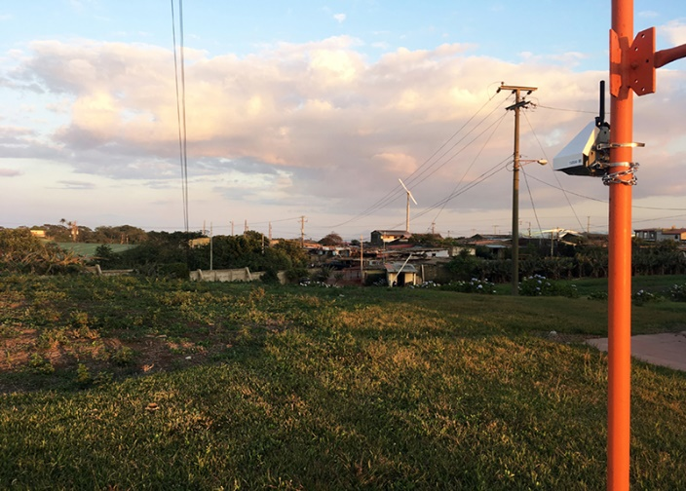

Figure 12 A continuous air monitoring sensor assembly mounted to a pole

APCD will monitor odor-causing chemicals, including TVOCs and H2S, in the IBC with the aid of real-time, continuous, portable sensors, similar to the setup shown in **Error! Reference source not found.**. As mentioned above, real-time sensors enable additional analyses including weather effects and time-of-day impacts. The sensors will be powered by solar panels, enabling deployment of sensors to areas that may not have readily available electricity, such as the Tijuana River Valley. APCD plans to use the collected data to forecast and notify the public of potential odor issues as quickly as possible.

### Meteorology

The two main factors that determine the air pollution concentration at a given location are meteorology and source emissions, both of which vary over time. Source emissions, which include facility, mobile, and area emissions, are calculated by APCD and CARB. APCD will measure meteorological parameters such as wind speed, wind direction, and temperature at the monitoring sites when possible or obtain meteorological data from nearby stations that can be considered representative. Though weather data at the fixed monitoring sites are not sufficient to identify individual pollution sources, these data can potentially support general source apportionment to separate, for example, local traffic sources versus more regional sources of air contaminants.

In addition to the small-scale effects that drive air pollution concentrations, a large-scale meteorological phenomenon increases air pollution concentrations during the colder conditions of winter. **Error! Reference source not found.** illustrates this effect that controls the amount of air in our layer of the atmosphere.

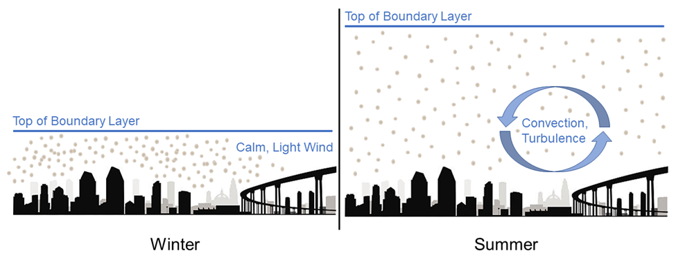

Figure 13 Schematic of atmospheric boundary layer heights during winter and summer. Both images contain the same total number of atmospheric pollutants, illustrating the main cause of higher air pollution levels in the winter

## Monitoring Sites and Sampling Plan

Monitoring locations are a crucial aspect of any air monitoring plan. Sites take many forms, including standalone trailers, chain link enclosures, a utility pole with a sensor or sampling canister mounted upon it, and more. Monitoring site locations depend on many factors, including, but not limited to:

* Community input
* Suitability
  + Electrical power and/or network availability
  + Barriers or obstructions
  + Land availability and security
  + Redundancy
* Available resources
  + Staff
  + Equipment

This section describes the process by which APCD has determined prospective monitoring sites based upon community-identified areas of concern. These potential sites and monitoring equipment will be shared with IBCSC members and the community to ultimately determine site locations and which monitors will be deployed to each site. It is unlikely that all proposed sites become monitoring sites, and site locations will almost certainly change over time. Therefore, a list of active and historical monitoring sites will be maintained on the APCD Community Monitoring webpage.

APCD already performs air monitoring within the IBC. The Ambient Monitoring Program, which is separate from the Community Monitoring Program, maintains the DVN site, which has available space for Community Monitoring Program equipment. Additionally, a site dedicated for use by the Community Monitoring Program has been operated at the Fire Station 29 in San Ysidro (SAY) since October 2019. Finally, a site at the California Highway Patrol Commercial Vehicle Enforcement Facility checkpoint in Otay Mesa (CHP) is under development.

APCD will continue to deploy monitoring equipment as sites become available. Monitoring will continue for multiple years with the following milestones in mind:

* Monitoring start date
* Emission reduction strategy implementation, including:
  + Community Emission Reduction Program (CERP) implementation by APCD
  + Infrastructure projects by US and Mexico federal governments to reduce wastewater contamination of Tijuana River
* Sustained, statistically significant pollution level reductions over at least three years and preferably five years

After five years of consistent data demonstrating the effectiveness of emissions reduction strategies, APCD will reconsider the need for ongoing air monitoring.

### Community Input

As mentioned above, community input is a vital aspect of community monitoring – both broadly and specific to monitoring locations. A list of potential monitoring sites will be generated by APCD using community feedback. Final approval by the IBC Steering Committee will be required for each monitoring site.

Below, a series of maps displays the feedback received from community members during IBC steering committee meetings, followed by a summary of the common throughlines of these conversations.

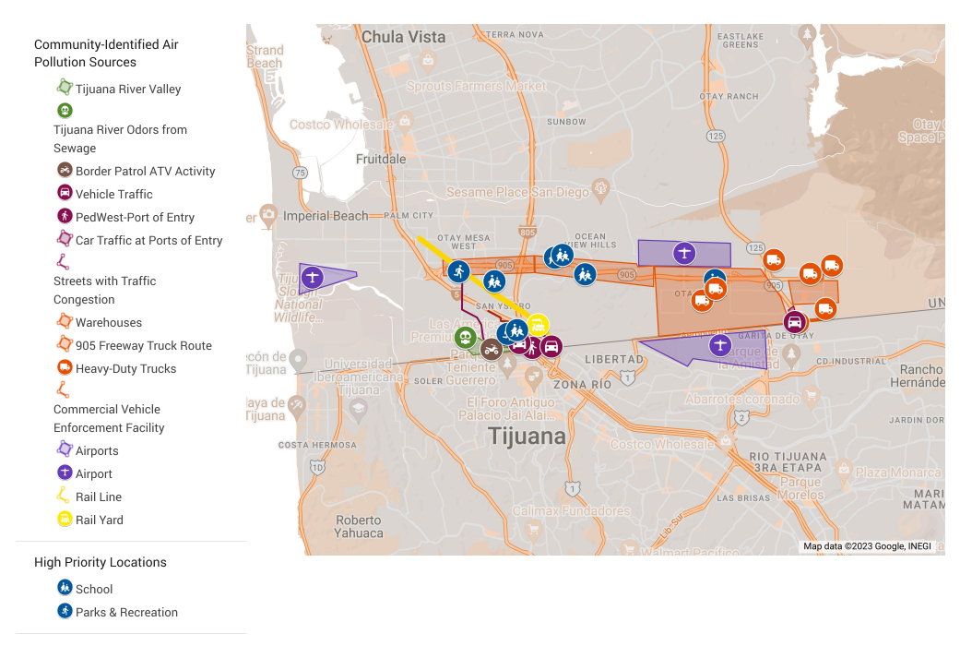

Figure 14 Annotated map of the entire IBC, including areas of concern highlighted by IBCSC members

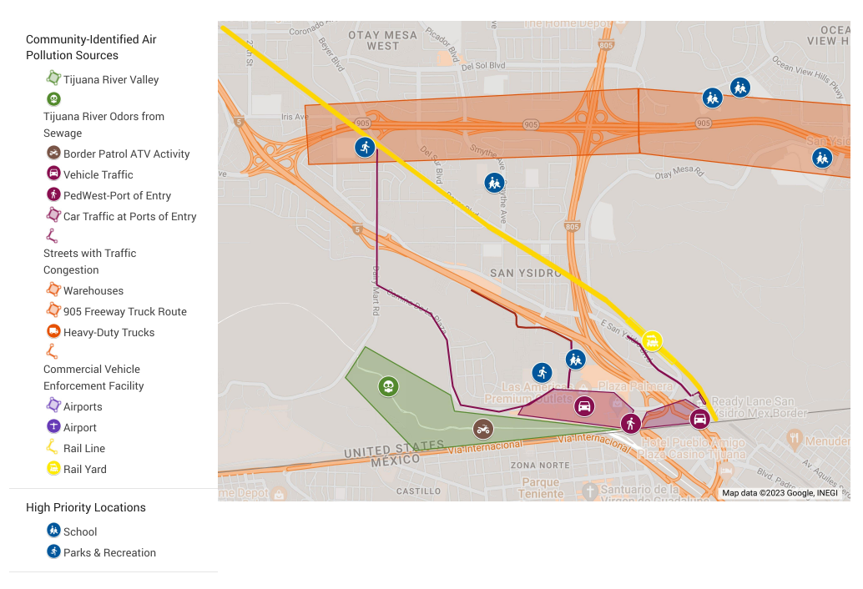

Figure 15 Annotated map of San Ysidro, highlighting areas of concern cited by IBCSC members

Figure 16 Annotated map of Otay Mesa, highlighting areas of concern cited by IBCSC members

#### International Border – Ports of Entry

Community members frequently cited automobile and heavy-duty vehicle traffic at the San Ysidro and Otay Mesa ports of entry as sources of concern. Vehicles must endure long waits, often several hours in length, when crossing from Mexico to the United States. These idling vehicles, particularly those with diesel engines, emit toxic pollution into the air. On the US side of the border, these vehicles are often backed up on Interstate 5 and on local streets (e.g., Dairy Mart Rd., Calle Primera, Willow Rd., Camino de la Plaza, and East San Ysidro Blvd.) near homes, businesses, schools, and parks. As mentioned previously, both San Ysidro and Otay Mesa rank in the 100th percentile for traffic density in California.

#### Tijuana River Valley

Community members also emphasized the odors emanating from the Southwest section of the Tijuana River Valley, describing negative health outcomes and diminished quality of life. These odors stem from untreated sewage and wastewater in Mexico that is transported by the Tijuana River across the international border. Additionally, Border Patrol operation of ATVs in the area has caused large clouds of dust to drift into the neighborhoods of west San Ysidro.

#### Airports

Two airports can potentially affect the air quality in the IBC: Brown Field Municipal Airport in Otay Mesa and the Tijuana International Airport on the Mexican side of the border. APCD will determine if existing (DVN) and proposed (CHP) sites are suitable locations for airport monitoring, or if additional site locations should be explored.

#### Schools, Parks, and Senior Centers

Due to children’s and the elderly’s heightened vulnerability to air pollution, the community expressed concern over common outdoor gathering places, particularly schools, parks, and senior centers. Larsen Field was specifically noted for its proximity to the San Ysidro Port of Entry, Interstate 5, and Las Americas Premium Outlets. Wilson Elementary School and San Ysidro High School were also elevated as potential monitoring sites.

#### California State Route 905 and Warehouses

Another potential concern is CA SR 905, which is used by many heavy-duty vehicles to ship goods across the border. There are new housing developments, which can expose residents to DPM and other pollution. Additionally, many warehouses have been constructed in the IBC as destinations for heavy-duty trucks to deliver goods.

### Suitability

Proposed monitoring sites must be evaluated for suitability for air monitoring. The following factors are considered when determining whether a site can be used effectively to monitor for air pollution:

#### Electrical and Network Availability

Much of the air monitoring equipment used by APCD requires a substantial amount of electrical power to operate. Underdeveloped areas, such as the Tijuana River Valley, may not have the electrical infrastructure to support traditional air monitoring equipment. Although electrical generators are a potential solution to this problem, this introduces both additional cost and the potential for interfering emissions from the generator itself. APCD will utilize equipment that can be powered by solar energy or batteries when applicable, and equipment that requires a connection to the electrical grid will be prioritized at sites that can accommodate.

Some sampling generates continuous data, which is delivered in real-time to the APCD network. This requires an internet connection, which in turn necessitates either a router for Wi-Fi network connectivity or cellular network functionality. Each continuous instrument has its own network requirements that will dictate where it can be deployed.

#### Barriers, Obstructions, and Interferences

Air pollution can be blocked or restricted from reaching an air monitoring instrument by the nearby buildings, trees, and topography. Additionally, nearby sources can bias measurements; for example, trees are known emitters of certain VOCs. While the VOCs emitted by trees tend to be less directly harmful to human health than those from other sources, these chemicals can still influence VOC measurements and serve as ozone precursors.

#### Availability and Security

When constructing a monitoring site, APCD needs to obtain permission from the property owner, typically in the form of a lease agreement. This lease agreement dictates the footprint of the monitoring site, the duration of the lease, and more. When leases expire, property owners can choose whether to renew lease agreements. Land availability can also pertain to other suitability aspects, such as whether electrical power can be extended to the area by SDGE.

APCD must also consider security with its monitoring sites. Air monitoring equipment can be very expensive, and so a suitable monitoring site must have sufficient security to ensure equipment will not be damaged or stolen. Security strategies can include, but are not limited to, chain link fences, padlocks, and security cameras. Also, APCD staff must be able to safely access the site to perform maintenance, deploy and decommission instruments, and more.

#### Redundancy

As resources are limited, APCD will avoid deploying equipment to an area that is already served by another monitor. For example, a BC monitoring instrument (Met One BC1060) has already been deployed to the Fire Station 29 in San Ysidro. If BC monitoring were proposed at the San Ysidro Community Park, APCD may not move forward with deployment to that monitoring site on the grounds that BC is already monitored just a short distance away.

#### Staff and Resources

APCD has a team dedicated to all air monitoring performed under the Community Monitoring Program. This group serves the Portside Communities in addition to the IBC. The equipment procured for this program is also designated for both communities. As such, APCD must decide how to allocate resources equitably to both communities, which affects how many monitoring sites can be maintained and how many instruments can be deployed to a given site. In the future, APCD may choose to allocate further resources toward hiring additional staff and/or obtaining more air monitoring equipment once funding is available.

### Field Sampling and Maintenance Plan

Equipment for community air monitoring will be deployed to sites as they become available. Table 3 summarizes the monitoring sites currently operational or in development in the IBC. Monitoring is already being conducted at the DVN and SAY sites.

Table 3 Current air monitoring sites in IBC  
*Pollutants that are not currently monitored, but will be monitored upon completion of the expansion of the San Ysidro Fire Station #29 site

|  |  |  |
| --- | --- | --- |
| **Site** | **Start Date** | **Pollutants Monitored** |
| DVN | July, 2014 | Toxic Metals, Toxic VOCs, BC, EC |
| SAY | October, 2019 | BC, Nitrogen dioxide (NO2)*, H2S*, PM2.5*, Toxic Metals*, Toxic VOCs*, EC* |

Although currently only BC is monitored at SAY, an expansion of the site in January 2023 will enable more equipment to be deployed to the site for additional pollutant monitoring.

To better characterize the pollution levels at the community level, additional potential monitoring sites will be surveyed for suitability, and more air monitoring equipment will be deployed to selected sites. Table 4 lists the potential sites and some key characteristics for each.

Table 4 Potential sites for air monitoring in the IBC

|  |  |
| --- | --- |
| **Potential Site** | **Notes** |
| Otay Mesa Border Protection Checkpoint* | **\*Projected deployment of monitors in 2024;** monitoring Toxic Metals & VOCs, BC, and EC |
| San Ysidro International Border Port of Entry | 100th percentile for vehicle traffic in CA; pedestrian foot traffic |
| Las Americas Premium Outlets | Near freeways, port of entry |
| Willow Elementary School | Near freeways, port of entry |
| Larsen Field | Near freeways, port of entry |
| San Ysidro High School | Near CA SR 905, warehouses, Brown Field Municipal Airport |
| Tijuana River Valley | Odor source; electricity limited |
| San Ysidro Civic Center | Close to SAY site |
| Casa Familiar | Close to SAY site |
| Southwestern College – Otay Mesa | Near Brown Field Municipal Airport |
| Vista del Mar School and/or Ocean View Hills School | Across CA SR 905 from San Ysidro High School |
| Smythe Ave Elementary School | Inside I-5, CA SR 905, I-805 boundary |
| Howard Lane Neighborhood Park | Inside I-5, CA SR 905, I-805 boundary |
| San Ysidro Health Center | Near train tracks; inside I-5, CA SR 905, I-805 boundary |

APCD coordinates closely with CARB to ensure that the two agencies implement a monitoring network that broadly covers the IBC while utilizing available resources efficiently and without redundancy.

#### Sampling Schedule

All non-continuous sampling will follow the official EPA one-in-6 (1:6) schedule, meaning one 24-hour sample will be collected every six calendar days. 1:6 sampling enables day-of-week analysis, as a different day will be a sampling day each week; for example, if a Wednesday is a sampling day, the subsequent sampling will occur on a Tuesday, etc. Continuous monitors will gather and report data throughout every day, all year long, except for routine maintenance and necessary repairs.

#### Maintenance Tasks and Schedule

An air monitoring plan must prioritize gathering high-quality, useful data. Several procedures employed by APCD will ensure that sampling, shipment, and analysis do not introduce inaccuracy, errors, or other problems into the data reported to the community. Some of these procedures are summarized below, while a more complete list including technical specifications will be provided in the Supplemental Document.

##### Calibration

Instruments undergo routine calibration to ensure that a value measured and reported by the instrument matches the actual, or “true,” value. In general, calibration involves exposing the instrument to a standard with a known value and altering the instrument’s settings to achieve a measured value within an acceptable range of the true value. For example, a temperature calibration might involve verifying the ambient temperature and adjusting the instrument’s temperature settings to match the true current ambient temperature.

##### Flow and Leak Checks

Air monitoring equipment and the samples and data it generates can be drastically affected by any issue with airflow or leakage. Therefore, periodic flow and leak checks are performed to ensure that instruments are performing within manufacturer's specifications.

##### Audits

The air monitoring instruments are audited to ensure accurate and consistent results. Chemists examine all parts of the instruments and verify they are functioning properly by testing them with known values and ensuring they are within acceptable limits. Any issues found are fixed to provide accurate air pollution information. For example, the BC measuring instrument is regularly checked to ensure the air flow is at its required rate of 2 liters per minute.

##### Maintenance Frequency

Required tasks vary by equipment and are summarized below in Table 5. Maintenance ensures that equipment continues to operate correctly and produce reliable, high-quality data.

Table 5 Maintenance tasks and frequency by program, equipment type

|  |  |  |
| --- | --- | --- |
| **Target** | **Equipment** | **Maintenance & Frequency** |
| Elemental Carbon | Met One Super SASS | * Flow & leak verification – monthly * Calibration – upon deployment, semiannually, and upon decommission * Audit – semiannually * Cartridge inspection – annually |
| Toxic Metals | Met One E-Seq-FRM | * Flow & leak verification – monthly * Calibration – upon deployment, semiannually, and upon decommission * Audit – semiannually * Cartridge inspection – annually |
| Black Carbon | Met One BC1060 | * Flow & leak verification – monthly * Calibration – semiannually * Audit – semiannually * Tape replacement – as needed |
| Toxic VOCs | Entech Flow Controller | * Calibration – every sample |
| Odor-causing Chemicals | Sensor Assembly | * Cleaning – semiannually or as needed * Sensor pod replacement – biennially or as needed |

#### Make-up Sampling

Occasionally, unforeseen events can prevent APCD from following the official EPA 1:6 sampling schedule. When this occurs, APCD will collect a 24-hour at the next earliest possible date, then resume following the official EPA schedule. If a single sample is missed at a site with collocated monitors, then no make-up sample will be scheduled, and the successfully collected sample will represent that sampling day with no collocated sample.

## Roles and Responsibilities

The air monitoring to be conducted in the IBC will require work by numerous individuals from various organizations and agencies, including APCD, contract laboratories, CARB, and the IBCSC.

### San Diego County Air Pollution Control District

APCD will maintain a dedicated AB-617 team responsible for the community air monitoring program. This team will include chemists, technicians, program coordinators, and more. Their responsibilities will include procuring and deploying monitoring equipment, analysis of monitoring data, maintenance and upkeep of equipment, establishing and overseeing monitoring sites, and communicating monitoring results to the IBC.

#### Chemists

APCD chemists will primarily handle the data processing and analysis functions within the community air monitoring program. Data processing involves verifying that data quality objectives are met, formatting data for sharing, extracting valuable information such as trends, and communicating these results to the IBCSC. Analysis will include examining trends on a deeper level, assessing each monitoring site’s value, pinpointing areas of concern and potential pollution sources, evaluating emissions reduction strategies, and more. Chemists are also responsible for instrument audits and some maintenance tasks, including some calibrations and all audits. Chemists receive peer training and attend manufacturer trainings when available, and they are supervised by the senior chemist for the Community Monitoring Program.

#### Technicians

APCD technicians primarily handle the air monitoring equipment used in sampling. The technicians deploy, calibrate, and maintain these instruments to ensure their performance and therefore the quality of the sampling data. They are also responsible for upkeep of monitoring sites and instrument troubleshooting in the event of a malfunction. Technicians and chemists regularly communicate to maintain the equipment in the air monitoring network. Technicians receive peer training and attend manufacturer trainings when available, and they are supervised by the APCD Supervising Technician.

#### Program Oversight

Staff in the Office of Environmental Justice will convene monthly IBCSC meetings that are open to the public. Agendas will be co-developed with IBCSC members prior to the meeting, and APCD staff will coordinate logistics (i.e., zoom, location, childcare, interpretation, refreshments, updating website with meeting information and materials, etc.) with the support from a consultant. Additionally, with the support of CSC members, APCD staff will conduct outreach to inform and invite the general public within the AB-617 community to attend these meetings. Staff in the Office of Environmental Justice will intentionally build relationships with IBCSC members and other engaged community members and serve as the main point of contact between the community and APCD staff. This office will be available to answer community questions, share requested information, and make program improvements based upon feedback. Lastly, the Office of Environmental Justice will support the development of popular education materials and presentations to enhance the accessibility of data and information to the community.

### Contract Laboratories

Contract laboratories will receive and analyze the samples collected by APCD. The contract laboratories determine the concentration level within each sample and report this data to APCD on a quarterly basis. Contract laboratories will also be responsible for some of the data quality verification. APCD decided to utilize third-party laboratories for analysis to maximize the amount of sampling that can be performed, rather than being limited by the availability of personnel and equipment.

### California Air Resources Board

CARB assists agencies by providing guidance toward the development of CAMPs. The criteria for these important documents are outlined in the CAPP Blueprint. When a community is selected for the CAPP, local air districts must commence air monitoring within 12 months. Throughout development and implementation of the Community Air Monitoring Plan, CARB staff provide technical guidance and support, such as:

* A community liaison available to answer monitoring questions
* Data analysis
* Technical/monitoring support

CARB staff also assists APCD with monitoring implementation timelines and reviews the monitoring plan for compliance with the Community Air Protection Program Blueprint, including the checklist for community air monitoring evaluation in Appendix E that outlines the 14 elements required for a successful Community Air Monitoring Plan. Throughout the review process, CARB will collaborate with APCD to discuss how criteria for each element are met, address concerns, and point out missing information. CARB also provides a formal review of the Community Air Monitoring Plan that will be posted to the APCD website.

### International Border Community Steering Committee

The IBCSC broadly serves as a liaison between APCD, CARB, and the community. APCD relies on the IBCSC to increase its understanding of the community, identifying its needs and concerns, informing potential air monitoring site locations, and connecting with relevant community and agency contacts. In addition, the IBCSC has been and will continue to be crucial for not only CERP co-development and implementation, but it will also serve an important role in distributing the most up-to-date information to members of the community. As air monitoring activities in the IBC grow and develop, sub-committees will be formed as needed to facilitate IBCSC needs. Finally, the IBCSC holds APCD accountable to successfully implementing and achieving CERP strategies and goals.

### Casa Familiar

APCD has worked closely with Casa Familiar, a community development organization for South San Diego. Casa Familiar has assisted APCD in organizing Steering Committee meetings and disseminating information to the community. Casa Familiar has also initiated air monitoring efforts independent of APCD’s AB-617-funded program, including targets such as carbon monoxide (CO), nitrogen monoxide (NO), and PM2.5. While APCD will not serve in any advisory or training role for Casa Familiar’s air monitoring, the two organizations will share data with one another for further analysis of air quality in the IBC. For more information on Casa Familiar, please visit their website ([Casa Familiar – Enhancing Quality of Life](https://www.casafamiliar.org/)).

### San Diego State University – School of Public Health

Researchers from San Diego State University’s School of Public Health have been important partners in identifying key community stakeholders and informing current air quality monitoring efforts and other public health related research in the community. For more information, please visit their website ([SDSU – School of Public Health](https://publichealth.sdsu.edu/))

### Mexican Government Agencies

In addition to APCD’s partnerships with stakeholders on the U.S. side of the international border through the IBCSC, APCD is also in close communication with Mexican environmental and government agencies by leveraging efforts through the U.S.-Mexico Border Environmental Program: Border 2025. Within the framework of Border 2025, APCD co-chairs the San Diego-Tijuana Air Quality Task Force, a group of governmental agencies, community-based organizations (CBOs) from both sides of the border, members of the public, and other stakeholders who meet quarterly to coordinate on the implementation of projects that support shared air quality goals for the binational air basin. Through this Task Force, APCD exchanges information and data with Mexican stakeholders with the goal of having more comprehensive information on air quality on both sides of the border and identify opportunities for binational collaboration on improving air quality for communities on both sides of the border. Mexican agencies and community members have been invited to participate in the IBCSC meetings. Collaboration and coordination with stakeholders across the border will continue.

# Section 2: Air Monitoring Data

The air monitoring data collected and reported by instruments and laboratories can be complex and disorganized. Before data results are communicated to the IBC, APCD reviews and processes the data into a manageable, accessible format. APCD technicians perform instrument calibration, maintenance, and sample collection, while APCD chemists are responsible for all data quality assurance and control, management, and analysis, which are summarized in Figure 17 and in text below.

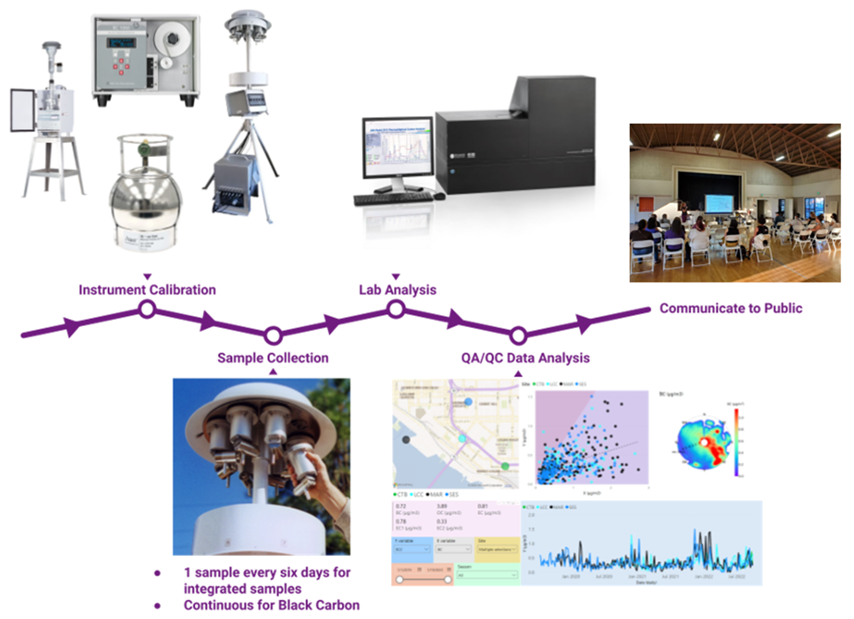

Figure 17 Visual summary of APCD’s process for gathering sampling data, performing analysis, and communicating results and trends to IBCSC and IBC residents

## Quality Assurance and Control

All sample data is reviewed to ensure it meets data quality standards. Each instrument and each program have specific technical requirements that must be met for data to be scientifically defensible. Quality assurance and quality control procedures have been instituted to ensure that these requirements are met. Quality assurance procedures seek to prevent any quality issues from affecting data, while quality control procedures determine whether ongoing sampling is producing satisfactory data.

Data should exhibit high precision and accuracy with as little bias as possible while achieving maximum completeness. Precision, accuracy, bias, and completeness are explained below, and more detailed descriptions of routine procedures to maintain data quality are provided in the Supplemental Document.

### Precision

Data precision refers to how reproducible the data is. In other words, does analyzing the same sample multiple times produce the same results? Per the model presented in Figure 18, precision can be thought of as hitting a target in nearly the same spot repeatedly. Data precision is ensured by both **replication** and **collocation** of samples. Sample replication involves analyzing a given sample multiple times in the exact same manner. Collocation means two different samples are collected at the same location and time with the same method and analyzed in the exact same manner. All replicate and collocated samples must be within 25% of one another, in terms of measured concentration, to be considered valid.



Figure 18 Visual representation of precision, accuracy, and how they are different. Precision answers whether analyzing the same sample multiple times produce the same results, while accuracy measures how close a measurement is to the actual, “true” value. In the top right, the ideal scenario is shown surrounded by a green box: simultaneously high precision **and** accuracy

### Accuracy

Data accuracy refers to how close a measured value is to the actual, or “true,” value. Per the model presented in Figure 18, accuracy can be thought of as hitting at or near the bullseye on a target. Accuracy is verified by conducting multiple calibrations on monitoring and chemical analysis equipment. As mentioned in Section 1: – Field Sampling and Maintenance Plan – Calibration, calibration involves exposing the instrument to a standard with a known value and altering the instrument’s settings to achieve a measured value within an acceptable range of the true value. Data accuracy will also be maintained through leak checks of all monitoring equipment, as leaks can introduce contamination or other interferences that can affect data quality.

### Bias

Bias can be introduced into data from incorrect or flawed sampling or analysis procedures. In other words, data results ***should not differ*** when different personnel perform various monitoring tasks ***nor*** when separate instruments measure the same sample. Technicians perform monthly flow and leak checks on all deployed instruments to ensure that all instruments are performing to manufacturer’s specifications. In addition, chemists perform semiannual audits on all equipment to ensure personnel actions are not biasing the data.

One additional procedure to detect bias is the proficiency test. Samples of known concentration(s) are distributed to labs, where the samples are analyzed. Resulting data from all participants are compared both among peer laboratories as well as against a referee laboratory, which serves as a standard by which other labs measure themselves.

### Completeness

Completeness is a measure of the amount of valid data obtained from a measurement system  
compared to the amount that was expected to be obtained under ideal conditions. The minimum acceptable data completeness rate is 75%.

### Data Control Limit Exceedances

When data does not pass a certain quality criterion, one of three approaches will be taken: reanalysis, nullification, or qualification. Nullification and qualification are documented by applying certain codes to the data set that correspond to the specific quality criterion that was not met. Specific criteria and the resulting codes are provided in detail in the Supplemental Document. Data sets are formatted for upload to the EPA air pollution database, Air Quality System (AQS). Data is also backed up to internal APCD servers. In the event of an error in the processing or management of the data, backup files will be available, and if necessary, a corrected version of the AQS file will be submitted.

#### Reanalysis

If a quality issue can potentially be resolved by repeating the sample analysis, then laboratory personnel will be instructed to do so. For example, if an error during analysis of a canister sample results in invalid data, and enough of the air sample remains inside the canister, then the sample can be reanalyzed, and the resulting data can replace the errant data.

#### Nullification

Certain data quality standards must be met for sample data to be considered valid. If the data is not valid *and* the sample cannot be reanalyzed, then the sample data must be nullified. This means that the pollution level, or concentration, will not be reported for that particular sample. Instead, a code will be reported that corresponds to the specific error or quality failure that prompted the nullification.

#### Qualification

Qualification results from a quality failure or error that is less severe than nullification. In this case, the pollution level is still reported, but an additional code is also reported that corresponds to the specific error or quality failure.

## Data Analysis and Management

The data gathered at monitoring sites is divided into two types: ***time-integrated*** and ***continuous***. Time-integrated samples are collected over and representative of a specified period, while continuous sampling generates data indefinitely at regular intervals. Different procedures are necessary for handling each data type.

Time-integrated data is obtained through 24-hour filter-based or canister-based sampling at monitoring sites. These samples are submitted to contract laboratories for analysis, who send the resulting data to APCD on a quarterly basis. The lab data is reviewed for quality and made available to the community through various channels, which will be discussed below. Because time-integrated samples are collected over 24-hour periods and submitted to contract labs for analysis, data takes longer to become available to the public compared to continuous data, which is available in near-real time.

Continuous data includes measurements such as BC and data from portable sensors. This data is transferred to the APCD server via internet, updates every five minutes, and undergoes initial automated quality checks. The data is then averaged and displayed for public access on a platform that will be developed by APCD to provide near-real-time information on air pollution levels.

Besides the air quality data itself, quality metrics and other metadata aretracked using various forms; any handwritten forms are digitized to be stored in APCD’s server, and the hard copies are organized and stored at APCD headquarters.

The general process for converting raw data from sampling into a format that APCD chemists can analyze and draw conclusions from involves the following steps:

* Receive data from either continuous sampling instrument or contract laboratory
* Ensure data are complete
* Ensure data meet all quality requirements pertaining to the type of pollution being analyzed
* Nullify (i.e., remove) any data points that do not meet the quality requirements
* Qualify any data points that may be outliers or have a unique attribute, including but not limited to:
  + Fire nearby during sampling
  + Trucks loading/unloading near monitoring site
  + Fireworks
* Format data for upload to multiple websites for public access:
  + AQS database on EPA website <epa.gov/aqs>
  + CARB website <aqview.ar.ca.gov>
  + APCD website <sdapcd.org>
* Prepare data for analysis:
  + Unit conversion
  + Separate data based on site and target
  + Arrange data graphically or visually
* Analyze data
  + Look for patterns or trends
  + Prepare presentations and updates for IBCSC

Data analysis is critical for developing goals and strategies to decrease air pollution levels. The data gathered will be used to inform the CERP, a document that details the measures being taken to improve air quality in the region. Pending available resources, the following analyses will be performed on data to keep the community informed about pollution levels and provide valuable insights for the CERP:

* Concentration Analysis: APCD will analyze the pollution levels at monitoring sites and investigate temporal patterns such as seasonal, time-of-day (diurnal), and day-of-week changes to help the community understand when they may be at risk of exposure to high pollution levels
* Compliance Analysis: This analysis determines whether pollution levels measured at IBC sites meet air quality standards set by regulatory agencies including EPA and CARB; this analysis can help identify areas in the IBC that require action to improve air quality and inform the development of the CERP
* Trend Analysis: APCD staff will investigate changes in pollution levels over time to identify patterns and determine the effectiveness of various CERP strategies
* Spatial Analysis: Spatial analysis helps increase understanding of where air pollution may be coming from (i.e., sources) and locate areas that may be at high risk for poor air quality
* Meteorological Analysis: APCD will incorporate available weather and climate data to understand how these affect air quality in the IBC; weather phenomena to be analyzed include wind speed, wind direction, temperature, and more

# Section 3: Community Engagement

AB-617 was passed with the simple, crucial goal of improving air quality, and more broadly quality of life, for communities overburdened by hazardous air pollution and other disadvantages. A successful Community Air Protection Program depends on the following three community-centered items, which will be elaborated upon in Section 3: Community Engagement:

* Ongoing, open communication between APCD, CARB, IBCSC, and the impacted community members
* Honest evaluation of program effectiveness and strategies
* Future actions to continue monitoring air quality and reducing air pollution exposure and levels

## Communicating Air Quality Information

Besides collecting and analyzing air pollution data, APCD will also present and share in a variety of ways the most up-to-date information possible to the steering committee and general public. The following strategies that have been identified by the IBCSC and community members will be applied:

* Formation of an air monitoring data subcommittee
* Quarterly presentations by APCD staff at IBCSC meetings
* Yearly progress reports on the monitoring network, pollution levels, and key takeaways
* Public availability of quality-reviewed data uploaded on a quarterly basis

Note that APCD will begin performing quality review on data reports from third party laboratories as soon as the data report is sent to APCD. Data turnaround times will vary, but typically data will be published before the end of the subsequent quarter; for example, quarter one data will be available by the end of quarter two.

### Air Monitoring Data Subcommittee

APCD and the IBCSC will collaborate to form a subcommittee responsible for preparing and editing presentations, informational materials, and reports that bridge the gap between highly technical air pollution data and community-level understanding. It is the APCD’s aim to ensure the information is accessible, relevant to the community’s lived experiences, informative about health impacts and risks, and can lead to actions to minimize day-to-day exposure to harmful air pollution.

### Presentations and Reports

APCD staff will present quarterly air pollution data updates, whether in person (see Figure 19) or remotely. Data from integrated samples, which must be submitted to contract labs, has a slower turnaround time, and therefore APCD will generally be presenting data from past months. While continuous data is available more rapidly, it also requires extensive quality review and organization before it is ready for presentation. Despite this, APCD will make every effort to present the most up-to-date information possible.

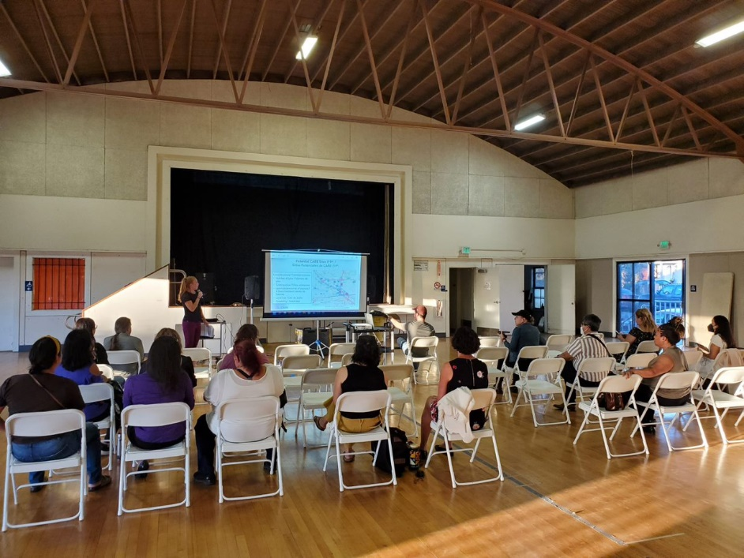

Figure 19 Presentation to IBCSC members at the San Ysidro Civic Center during the October 2022 Steering Committee Meeting

In addition to quarterly presentations, APCD will deliver yearly reports to track the progress of monitoring network development, CERP evaluation, pollution levels, and key takeaways. APCD will coordinate with the Air Monitoring Data Subcommittee to ensure information is accessible and understandable for community members.

### Publicly Available Data and Real-time Information

APCD will make air monitoring data available through a number of methods:

* Websites
  + [San Diego County Air Pollution Control District](https://www.sdapcd.org/) <sdapcd.org>
  + [California Air Resources Board - AQview](https://aqview.arb.ca.gov/home) <aqview.arb.ca.gov>
  + [United States Environmental Protection Agency - Air Quality System](https://www.epa.gov/aqs) <epa.gov/aqs>
* Consistent social media updates with emissions data and CERP updates presented in an accessible and meaningful manner
* Text alerts to notify community members about air quality and provide recommendations on how to limit pollution exposure; community outreach will be performed so IBC residents can self-select to receive text messages from APCD
* School Flag Program coordinated with Wilson Elementary School and San Ysidro High School to alert school staff and students to the local air quality forecast and enable protection of their health, especially those with asthma or other respiratory conditions; each day, the school raises a flag that corresponds to air quality
* Partnerships with community-based organizations (e.g., senior centers, healthcare facilities, and schools) to convey real-time air quality information to protect sensitive groups, including children and the elderly, when air pollution levels are deemed unhealthy, and to share information regarding CERP implementation and emissions data

## Program Evaluation

***Air monitoring*** is just one piece of the broader effort to improve air quality in the IBC. Gathering accurate air quality data is crucial for two reasons:

1. The Community Emissions Reduction Program will contain ambitious, concrete goals for lowering harmful emissions. These goals are developed in part by analysis of monitoring data, and attainment of these goals is measured using the ongoing analysis of air pollution levels
2. **Air pollution is a long-term problem.** Equipping the community with as much information about air quality as possible will enable them to make decisions and implement actions in their day-to-day lives to limit their exposure to harmful air pollution while CERP strategies, which address specific root causes of emissions, are developed and implemented.

The success of the Community Air Protection Program will be measured by evaluation of CERP strategies and identification of exposure risks. This will allow IBCSC members, the community, APCD, and CARB to periodically reflect on the following questions:

* Are CERP strategies leading to the proposed reductions in emissions and exposure?
* Do CERP strategies need to be amended, enhanced, or replaced?
* Are there tangible steps that IBC residents can take to protect themselves and their families from harmful pollution exposure?

The ongoing communications and reports from APCD to the IBCSC will seek to answer these questions for IBC residents. Also, APCD will regularly request feedback from IBCSC members, including at monthly meetings and during one-one-one meetings with APCD staff.

## Future Actions

Air monitoring data collected by APCD, including from past and future sampling, will be used for multiple purposes, including identification of areas of concern, development and evaluation of a Community Emissions Reduction Program, and implementation of exposure reduction strategies.

### Community Emissions Reduction Program

The Community Emissions Reduction Program, like the CAMP, is a document that identifies and summarizes important aspects of the CAPP to help achieve emission reduction goals in the community. Much of the same information is provided in each document, and though the two plans are highly interrelated, they differ in one key area: while the CAMP specifies, broadly speaking, how and where pollution data will be gathered and disseminated, the CERP identifies strategies that, when implemented, can reduce pollution levels at the source of emissions. The CAMP serves as a feedback mechanism for evaluating the effectiveness of the CERP. As monitoring data is collected and analyzed, CERP strategies are reviewed for effectiveness in reducing emissions and community exposures.

### Exposure Reduction

Air monitoring data can also inform actions that can be taken to limit the exposure of community members to harmful pollution. For example, trucking routes can be instituted to prevent heavy diesel emitters from driving or idling near parks, schools, senior centers, and other locations where vulnerable community members might frequently reside. Additionally, APCD performs data analysis to pinpoint additional exposure trends, such as what times of day or year typically show the highest levels of pollution, how weather affects these levels, or where certain hot spots may be. This data analysis can help inform exposure reduction programs, such as school flag programs to help protect vulnerable populations from the effects of air pollution, as well as other outreach programs to inform community members about the air pollution on different days and times to help them plan their outdoor activities accordingly.

### Land Use

By having comprehensive information about air pollution in the community, land use jurisdictions can identify opportunities to modify land uses as part of land use plan updates. For example, air monitoring data can be used to support the identification of areas where land uses that act as buffers between residences and major sources of pollution would be effective in reducing pollution exposure. Other land use strategies can include the development of more green spaces within a community or an expansion of the tree canopy in the community.

### Rule Development

Air monitoring data can help air pollution regulators identify opportunities for adopting rules that can further reduce toxic air emissions from polluting sources. For example, spikes in the levels of a particular contaminant could signal regulators to look for sources of those contaminants and asses the effectiveness of existing rules or develop new ones.

### Additional Monitoring

Data analysis can reveal hot spots as well as potential gaps in the monitoring network. Furthermore, as the IBC continues to grow and add new industrial and commercial facilities, the monitoring network will need to adapt over time. APCD will continue to assess its monitoring network and whether additional sites and/or equipment is needed, existing sites are delivering valuable data, and resources are being deployed as efficiently as possible. The overarching goal of the CAPP is to reduce exposure to harmful air pollution, and the monitoring performed by APCD in the IBC must contribute to the realization of this goal.